Functional Decomposition and Concept Generation

1. **Introduction**

Functional decomposition and concept generation is an important way of determining what a product will do and how it will accomplish it. A variety of ideas were put together in a group setting on what the functions of a finished product would be. Then, the group brainstormed ideas on how to complete each function. Finally, the group created 5 concepts for a finished product using concept ideas that would correctly complete each function.

1. **Functional decomposition**

Functional decomposition involves using the customer needs as a basis for determining the required functions of the product. These functions are not solutions, but rather abstract project requirements to fill with solutions later. The group brainstormed functions of the product based on the critical needs and engineering concepts previously discussed. Identified functions for the bridge shaker project in approximate order are listed below:

1. Attach to structure
2. Receive energy
3. Regulate power
4. Receive input on the desired frequency and timeframe to vibrate at
5. Determine set frequency
6. Show parameters on screen
7. Receive input to start vibration procedure
8. Convert electrical energy to mechanical energy
9. Increase or reduce frequency
10. Transfer energy to the bridge
11. Vibrate the bridge
12. Receive input to stop vibration of the bridge
13. Detach from structure

Once functions were identified, they were condensed and broken up into three categories: energy, material, and information. A functional decomposition diagram is shown in Figure 1 and is used to organize the functions and visualize interactions. The arrows identify preceding and subsequent functions depending on the head direction, and the order of functions increases from left to right. For example, receive energy precedes regulate power as indicated by the arrowhead and its position to the left of the other function blocks. As described by the functional decomposition diagram, the product must first attach to the bridge and receive electrical energy before regulating that energy and converting it into mechanical energy. That energy will be used to manipulate the frequency depending on set parameters acquired from a user. The user input will be measured and displayed after an initiation signal is received, and energy will be transferred to the bridge to induce vibration.

Figure 1: Functional decomposition diagram.

1. **Concept Combinations**:

The Concept Combination Table (CCT) shown in Table 1 serves to organize the possible solutions to the functional requirements of the project.

*Table* 1*: Concept Combination Table, CCT.*

With the subproblems and solutions listed out, it is easier to combine functional solutions to generate a total solution for the project. The CCT has allowed for ease of development in creating five designs for the Bridge Shaker project.

For most of the functions, the group attempted to create several solutions for the functional requirements which were broader in scope. However, for some functions, only limited solutions remained such as “Reducing/Increasing Frequency”, “Receive Power”, and “Regulate Power”. For increasing/decreasing the frequency, an Arduino or Motor Driver is the best option, as other solutions would be either overly complex or expensive. The “Receive Power” function in the CCT has so few solutions because there are not many ways to solve this apart from the most convenient options such as wall outlets, generators, and batteries. A similar thought process guided the creation of the “Regulate Power” function of which the Power Management Integrated Circuit (PMIC), microcontroller, or Metal Oxide Semiconductor Field Effect Transistor (MOSFET) seemed to be the most viable options. The other functions with more solutions have some with greatly desired methods and some that are not. For instance, attaching the bridge shaker via epoxy would be greatly undesired due to the difficulties inherent in working with epoxies such as the mess and effort in application. Other solutions seem to be no-brainers in their use, but there are some solutions where choosing the best option is not as simple. For instance, the method to convert electrical energy to mechanical energy has several options. The motor with an offset or linear weight and solenoids could both be great methods, but the choice will influence the remaining solutions of other functions like “Receiving Power”.

1. **Concept Generation:**

Five concepts were generated using the Concept Combination Table. A basic schematic and description of each concept was developed by the group. The following concepts were developed.

Table 2: Concept Generation; Concept 1.

Concept 1: A motor is powered by a wall outlet with power regulated by a microcontroller. The motor rotates an asymmetric offset weight to induce vibration by converting electrical energy into mechanical energy. User input on frequency and test time is gathered through buttons read through a microcontroller, which increases or decreases the frequency by altering the power. Energy is transferred to the bridge with a shaker weight. The shaker is attached and released from the bridge using clamps to the sides of the bridge.

Figure 2: Concept sketch 1.

Table 3: Concept Generation; Concept 2.

Concept 2: The power from the battery is put through a PMIC and goes to an Arduino. The Arduino takes keypad entries from the user to control the speed of the solenoids which impact the platform and induce vibrations in the bridge. The apparatus is connected to the bridge with bolts, and energy is transferred to the bridge through this connection.

Figure 3: Concept sketch 2.

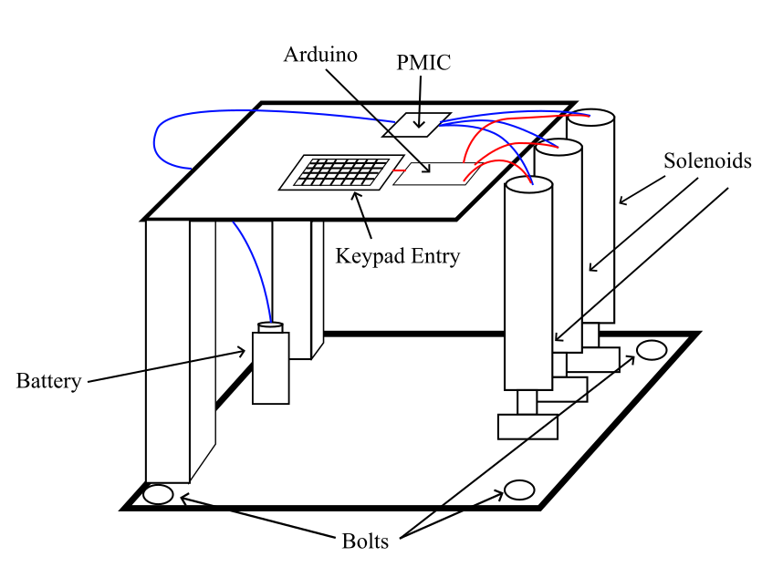

Table 4: Concept Generation; Concept 3.

Concept 3: A motor is powered by a separate generator. The voltage from the generator is regulated via a MOSFET. The DC Motor turns a pulley that draws the weight upward towards the top of the frame. Then, by control of the microprocessor, when given an input from the remote control, the device will drop the weight and pick it back up repeatedly until instructed to stop. The entire apparatus will be held down by rachet straps connected to the bridge and the mode of energy transportation will be via the counterweight.

Figure 4: Concept sketch 3.

Table 5: Concept Generation; Concept 4.

Concept 4: A wall outlet supplies power which is regulated by a microcontroller to an air compressor. This compressor powers a hydraulic actuator with a large surface area on the end to strike the bridge to induce vibration. The user inputs frequency and testing time via a touchscreen, which is read by an Arduino to increase or decrease the frequency by controlling the air compressor. The system is secured by ratchet straps, and energy is transferred to the bridge from the weight of the system.

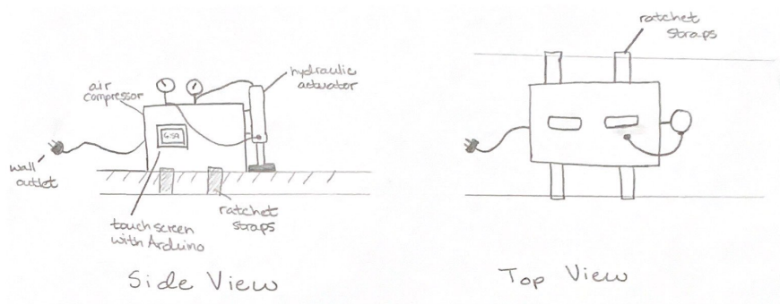

Figure 5: Concept sketch 4.

Table 6: Concept Generation; Concept 5.

Concept 5: A generator is regulated by a MOSFET and powers a motor with a linear weight. The motor is controlled by an Arduino which takes input from a keypad. The device is encased to protect the parts and the whole device is tied down with rachet straps. The energy is being transferred to the bridge through the linear weight being driven up and down by the motor and links.

Figure 6: Concept sketch 5.

1. **Research performed**

The keywords “mass shaker”, “structures”, and “test” into the Google Patent search engine revealed some relevant patents that were useful in illuminating methods of inducing vibrations. Patent EP2589947B1 [1] presents a high-frequency vibration system that uses the piezoelectric effect to induce vibration through a disk-shaped contact structure that the object sits upon. Patent SU325770A1 [2] was found that depicts a pneumatic vibrating device. This device uses compressed air alternately pushed into opposite sides of the cylinder creating a vibration. This patent resembles the hydraulic piston concept generated in the above section. Patent EP0566809A1 [3] shows a fruit harvester that clamps onto a tree trunk and uses linear impact vibrations to shake fruit off the branches. Its primary method of vibration inducement is motors with offset weights which are connected to an excitation rod attached to the tree trunk by a clamp, and the vibrations transmitted through the rod and the impacts acting on the tree cause the fruit to fall.

1. **Conclusion**

Concept generation can be a difficult task. Prior to concept generation, the functions of the device were laid out sequentially to give the team an idea of the technologies needed for each step. Next, the concept combination table was created to brainstorm ideas that could fulfill each function. Lastly, from this table concepts were generated that will satisfy all stakeholders. In doing so, some technologies were found to be unrealistic, or would not necessarily suit the needs of the sponsor. An example of this was the use of hydraulic pistons to convert electrical energy into mechanical energy. Discussion led to the conclusion that the pistons would not be able to alternate fast enough to produce the vibrations desired and that the fluid inside of the pistons would dampen the vibrations. On the other hand, it was determined that the DC motor, in combination with either linear weight oscillation or offset weight, would be the most likely conceptual design for any scenario. This keeps the design comparatively simple and easily controllable by the user. Even though the device will be simple, it will still be difficult to design the shaker to oscillate the bridge at the desired frequency. In another interview with stakeholder Joud Satme, he expressed concerns about the functionality of single-frequency excitement. This conversation led to the development of Design Five. The next step will be to evaluate the concepts after discussing them with the sponsor, Dr. Austin Downey, and ultimately selecting a design to move forward with.

**References**

[1] James P. Rogers, Abbas Mandvi, Chi Chin LEE, Chhour M Thong, Anthony Charles Buono, “High frequency vibration system”, European Patent 2589947B1, Feb. 12, 2020.

## [2] Н. А. Клушин, В. Н. Шмигальский, П. А. Маслаков, Э. П. Варнелло, Э. А. Абраменков “Pneumatic Vibrator”, Russian Patent SU325770A1.

[3] Domingos P. Sousa, Pedro J. Oliveira, “Improvements in the mechanical shaker for fruit harvesting”, European Patent 0566809A1, Oct. 27, 1993.